Phase 4 · Extend, Automate & Ship
Exercise 11: Document and Ship
Dev cycle | Update & Document (handoff)
CC features | README and ADR generation, /compact, /cost, git via generated commits, /install-github-app, production gap audit
Time | 45 min
You produce | A documented, committed, handoff-ready ExpenseFlow plus a production gap report

Objective
A PoC nobody can pick up is a dead end. You will generate the documentation an engineer needs to take over, manage context and cost on this now-long session, commit clean work, and produce the production gap audit that tells stakeholders honestly what it would take to ship for real.
Walk-through
1 | Generate the README
Documentation-first means the README explains the PoC to a newcomer. Have Claude write it from the actual code.
Type this prompt into Claude Code
Write README.md for ExpenseFlow: what it does, the stack, how to set up the venv and install on Windows, how to configure .env, how to run the server and the tests, and the full endpoint reference. Base it on the real code, not assumptions.
VALIDATE README.md contains the exact Windows setup commands you used, the .env keys, run/test commands, and every endpoint including the ones the skill added. A new teammate could start from zero.
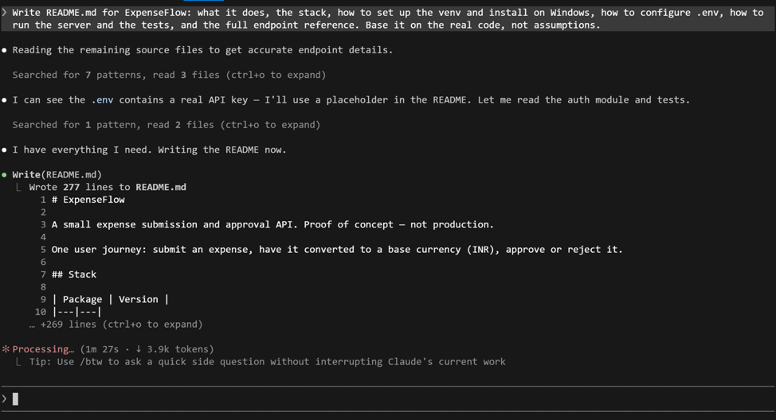

2 | Write the technical handoff and an Architectural Decision Record (ADR)
Beyond the README, engineering wants the why. Generate a one-page handoff and an architecture decision record for the money-as-integer choice.
Type this prompt into Claude Code
Create docs/HANDOFF.md (what it does, how it works, what a deployment engineer needs to know) and docs/adr/0001-money-as-integer-minor-units.md as a short ADR explaining the decision, the alternatives, and the consequences.
VALIDATE Both files exist. The ADR states the decision (integer paise), why (float rounding errors in money), and the trade-off (manual formatting for display). This is the artefact that survives after you have moved on.
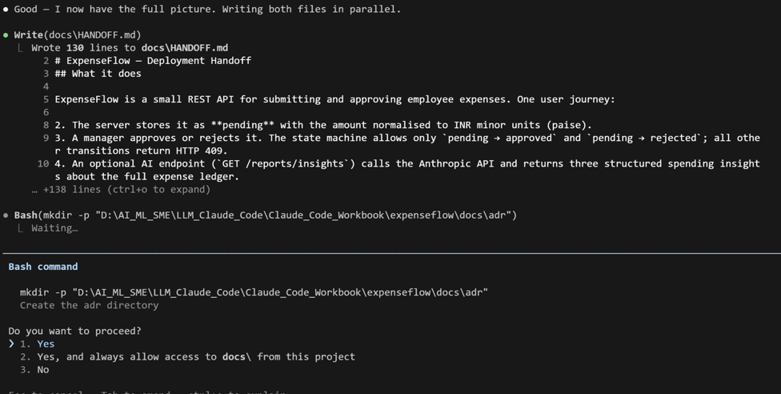
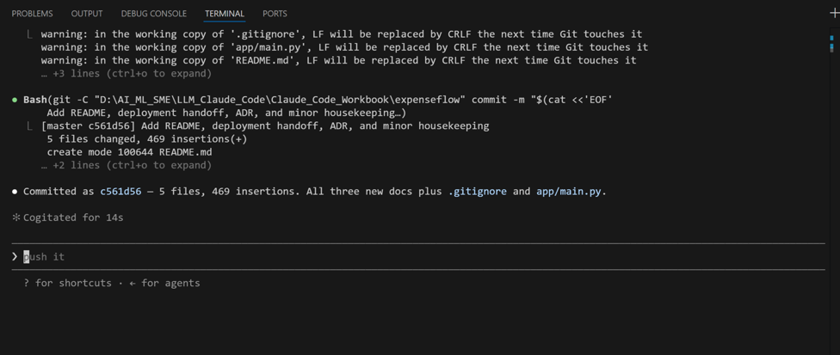

3 | Run the production gap audit
Finally, the honest reckoning. Have Claude assess what stands between this PoC and production, classify each gap, and estimate effort. This is what you take to stakeholders.
Type this prompt into Claude Code
Audit ExpenseFlow against a production bar: authentication and key rotation, input validation, rate limiting, observability and logging, error handling, database migrations and pooling, secrets management, tests and coverage, deployment and health checks, and data privacy for expense data. For each: state the gap, classify it blocking or deferrable, and give a rough effort estimate. Write it to docs/PRODUCTION-GAP.md.
VALIDATE docs/PRODUCTION-GAP.md lists gaps with blocking/deferrable labels and effort estimates. The honest total is far larger than the PoC itself: that gap, made explicit, is the most valuable thing you can hand a stakeholder before they greenlight engineering.
What success looks like
- README, HANDOFF, and an ADR exist and are accurate to the real code.
- You managed a long session deliberately with /compact and read the bill with /cost.
- A clean, conventional commit captures the work, and a production gap audit states honestly what shipping would take.
Common pitfalls (Windows and macOS)
- /compact summarises and keeps the thread; /clear wipes it. Do not /clear right before you need the project context for docs.
- Generated docs drift from code. Treat README and HANDOFF as living: regenerate them when the code changes materially.
- A gap audit that is too optimistic is worse than none. If Claude is rosy, push: 'what would a sceptical SRE add to this list?'
Stretch goal
Ask Claude to turn docs/PRODUCTION-GAP.md into a one-slide executive summary with a recommendation: greenlight, greenlight-with-conditions, or do-not-ship. You now have a documented, reviewed, ship-assessed backend.

